MTH 325 Fall 2024 – Exam 3 Skills 1—8

DO NOT ATTEMPT ANY SKILL WHERE YOU ARE ALREADY AT “MASTER” LEVEL!

**Skill 1: (CORE) I can outline a proof by mathematical induction.**

Consider the following proposition: For every integer $n≥1$, $1+3+5+⋯+\left(2n-1\right)=n^{2}$.

1. State the value of *n* that corresponds to the base case, then prove that the base case holds.
2. Clearly state the inductive hypothesis. Your answer should be phrased as a complete sentence. (No explanation is required here; simply state the inductive hypothesis.)
3. Clearly state what you would need to prove, after assuming the inductive hypothesis. Your answer should be phrased as a complete sentence. (You do not need to give a completed proof the statement; simply state what you would need to prove.)

**Skill 2: (CORE) I can outline a proof using direct, contrapositive, and indirect approaches.**

Consider the following proposition: Suppose that *n* is a positive integer. **If $2^{n}-1$ is a prime number, then *n* is a prime number.** (Note, you do not need to know what a “prime number” is to answer these questions.)

1. Clearly state what you would assume and what you would need to prove, if you were to prove this statement with a *direct proof*. (No further explanation is necessary.)
2. Clearly state what you would assume and what you would need to prove, if you were to prove this statement with a *proof by contrapositive*. (No further explanation is necessary.)
3. Clearly state all assumptions you would make, if you were to prove this statement with a *proof by contradiction* (also known as an *indirect proof*). (No further explanation is necessary.)

You are not being asked to give completed proofs here. Simply state the frameworks for each type of proof.

**Skill 3 (CORE) I can represent a graph in different ways, determine information (degree, degree sequence, paths of given length, etc.) about a graph using different representations, and give examples of graphs with specified properties.**

Consider the graph *G* given by this adjacency matrix:

1. Find the number of edges in this graph without drawing a picture of it and counting directly. Show your work or otherwise explain your reasoning.
2. Assume that the vertices are labeled *a, b, c, d, e, f* and the rows and columns of this matrix correspond to that ordering (so the first row and column represent vertex *a*, the second represent vertex *b* and so on). Draw a visual diagram of this graph with the vertices correctly labelled.
3. State the degree of each vertex. You don’t need to explain your answers here, just make sure they are right.
4. Give an example of a cycle of length 4 in this graph. If no such cycle exists, say so and explain your reasoning.

**Skill 4: I can determine whether a graph has an Euler trail or Euler circuit, and whether a graph has a Hamiltonian path or circuit.**

Consider the graph *G* shown below:



1. Determine whether this graph has an Euler trail, and explain how you know.
2. Determine whether this graph has an Euler circuit, and explain how you know.
3. Determine whether this graph has a Hamilton path, and explain how you know.
4. Determine whether this graph has a Hamilton circuit, and explain how you know.

**Skill 5: I can use a greedy algorithm to find a vertex coloring for a graph, and I can determine a graph's chromatic number.**

Consider the graph below:



1. Use a greedy algorithm to construct a proper vertex coloring for this graph. For the initial ordering of the vertices, use the degree of the vertices from highest degree to lowest, and in the case of a tie, use numerical ordering (low to high). Your work should consist of a list of vertices in the order in which they are considered; and the color assigned to each one, given as a non-negative integer. **A correct response must use the greedy algorithm discussed in class and the vertex ordering indicated here.**
2. State the chromatic number of this graph and explain your reasoning.

**Skill 6: I can determine whether two graphs are isomorphic; I can give an explicit isomorphism if they are, and an explanation if they are not.**

Given the two graphs below, state whether they are isomorphic. If they are isomorphic, give an explicit isomorphism between the two and explain why your mapping is really an isomorphism. If they are not isomorphic, give an explicit isomorphism invariant property that one has but the other does not have.

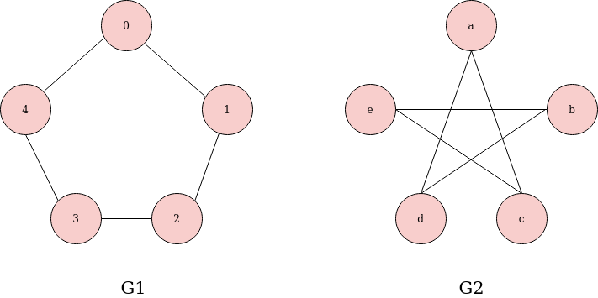

**Skill 7 (CORE): I can determine whether a graph is a tree and state information about it.**

1. Draw (or give a Python dictionary for) a graph that has 10 vertices and 10 edges. If this is not possible, explain why.
2. A graph has degree sequence 3, 3, 2, 2, 2. Decide whether the graph must always be a tree, must never be a tree, of could possibly be a tree (but might not be a tree). State your answer and explain your reasoning.
3. Consider the rooted tree shown below, with vertex 7 as the root. State the following. (No explanation needed but be sure to label your answers.)
   1. The children of vertex 4
   2. The parent(s) of vertex 12
   3. The height of the tree
   4. The leaves of the tree



**Skill 8: I can use Prim's Algorithm and Kruskal's Algorithm to construct a minimum spanning tree for a weighted graph.**

Consider the weighted graph below:

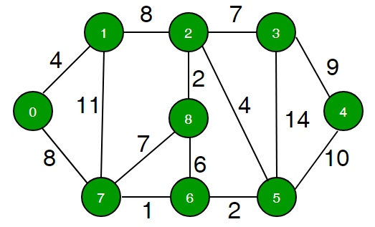

1. Use Prim’s algorithm, with initial vertex 2, to construct a minimum spanning tree for this graph. Your work should consist of a list of edges in the tree, given in the order in which they are added.
2. Use Kruskal’s algorithm to construct a minimum spanning tree for this graph. Your work should consist of a list of edges in the tree, given in the order in which they are added.